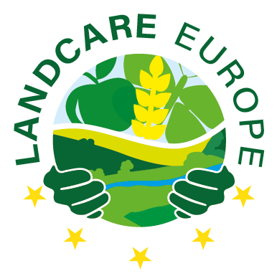
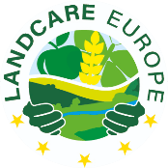
LANDCARE EUR OPE
Membership Application Form

Name of organisation: …………………………………………………………………………………………………..
In national language (if different) …………………………………………………………………………………………………..

Postal address: …………………………………………………………………………………………………..
Street name, …………………………………………………………………………………………………..
Postcode, City, …………………………………………………………………………………………………..
Country …………………………………………………………………………………………………..

Is the organisation headquartered and does it operate in Europe? – YES / NO
If no, where else? …………………………………………………………………………………………………..

Website (if available): …………………………………………………………………………………………………..
Organisation is represented by:
Name(s), First name(s): …………………………………………………………………………………………………..

Position/job title: …………………………………………………………………………………………………..

Phone number(s): …………………………………………………………………………………………………..
Incl. country code
Email address: …………………………………………………………………………………………………..
Incl. country code

…………………………………………………………………… ………………………………………………………………
Place, date Signature

More information about your organisation

- What status do you have in your country? (NGO, NPO, research institute, public body, company, administration office, …)

- What is the vision & mission of your organisation? (if applicable, copy & past or link to statement online)

- Motivation: Why do you want to join Landcare Europe? (max. 1000 characters)

- Are you an umbrella organisation or part of one (at national or European level)?

If so, how many (regional) organisations are part of the umbrella organisation?

If not, are there other organisations in your country that work with a Landcare approach or like you?

- Board representation? (if applicable, e.g. political, agricultural, conservation background; if available link to organisational structure)
Name | Function | Voluntary | Main employment at
- Yes
- No
- Yes
- No
- Yes
- No

- Have you collaborated with DVL in a project before?

If so, which?

- Have you collaborated with one of the other Landcare Europe Founding Members before? (Agri-Cultura-Natura Transylvaniae Association (ACNT); Baltic Environmental Forum (BEF) Lithuania; BoerenNatuur; Boerennatuur Vlaanderen; Fédération des Conservatoires d’espaces naturels (FCEN); Legambiente Lombardia; Brodsko ekološko društvo – BED; Sonairte)

If so, which?

- Please give us an overview over relevant projects you worked on during the past (5-10 years), including topic, length/duration (with dates), partners, budget, co-financing, type of project (e.g. LIFE, Interreg, etc.): (Please delete the example and add more rows, if needed)

Grantee | Programme (e.g. Life+, Horizon 2020) | Duration | Topic | Financial volume | Role in the project (Lead, Partner)
DVL | Pilot Project, European Parliament | 09/2021 – 08/2023 | Improving guidance and knowledge sharing between land managers, conservationists and local | 439,881 € | Lead (DVL)

- Which other networks and/or committees do you belong to?

- How do you collaborate with farmers? Please describe how. (max. 1000 characters)

